4.7 I respond to problems with collaborative technologies.

After you install a device or update a driver for a device, Windows Vista or Windows 7 may not start

*Windows Vista Ultimate Windows Vista Home Premium Windows Vista Home Basic*[*More...*](javascript:)

Support for Windows Vista without any service packs installed ended on April 13, 2010. To continue receiving security updates for Windows, make sure you're running Windows Vista with Service Pack 2 (SP2). For more information, refer to this Microsoft web page: [**Support is ending for some versions of Windows**](http://windows.microsoft.com/en-us/windows/help/end-support-windows-xp-sp2-windows-vista-without-service-packs)

Symptoms

After you install a device or update a driver for a device on a computer that is running Windows Vista or Windows 7, the operating system may not start.

Cause

This problem may occur if any one of the following conditions is true:

* The new device or the driver causes conflicts with other drivers that are installed on the computer.
* A hardware-specific issue occurs.
* The driver that is installed is damaged.

Resolution

To resolve this problem, use the following troubleshooting steps to determine the exact cause, and then take the appropriate action.

Start Windows Vista or Windows 7

1. If you installed a new device, remove the device, and then try to start the computer. If the operating system does not start, go to step 2. If the operating system starts, go to the "Resolve the cause of the startup problem" section of this article.
2. Start the computer, and then press F8. On the **Advanced Boot Options** screen, select **Last Known Good Configuration**, and then press ENTER. If the operating system does not start, go to step 3. If the operating system starts, go to the "[Resolve the cause of the startup problem](https://support.microsoft.com/en-us/topic/after-you-install-a-device-or-update-a-driver-for-a-device-windows-vista-or-windows-7-may-not-start-12c9a139-83bf-4002-bbd1-02054717877d#bkmk_3)" section of this article.
3. Start the computer, and then press F8. On the **Advanced Boot Options** screen, select **Safe Mode**, and then press ENTER. If the operating systemstarts in safe mode, go to the "[Resolve the cause of the startup problem](https://support.microsoft.com/en-us/topic/after-you-install-a-device-or-update-a-driver-for-a-device-windows-vista-or-windows-7-may-not-start-12c9a139-83bf-4002-bbd1-02054717877d#bkmk_3)" section of this article. If you cannot start the operating system in safe mode, go to the "[Use the Windows Recovery Environment to repair Windows Vista or Windows 7](https://support.microsoft.com/en-us/topic/after-you-install-a-device-or-update-a-driver-for-a-device-windows-vista-or-windows-7-may-not-start-12c9a139-83bf-4002-bbd1-02054717877d#bkmk_2)" section of this article.

Use the Windows Recovery Environment to repair Windows Vista or Windows 7

Important This section, method, or task contains steps that tell you how to modify the registry. However, serious problems might occur if you modify the registry incorrectly. Therefore, make sure that you follow these steps carefully. For added protection, back up the registry before you modify it. Then, you can restore the registry if a problem occurs. For more information about how to back up and restore the registry, click the following article number to view the article in the Microsoft Knowledge Base:

[322756](http://support.microsoft.com/en-us/help/322756) How to back up and restore the registry in Windows

To use the Windows Recovery Environment, you must have the Windows Vista or Windows 7 installation disc. To start the Windows Recovery Environment, follow these steps:

1. Put the installation disc in the disc drive, and then start the computer.
2. Press a key when you are prompted.
3. Select a language, a time and currency, and a keyboard or input method, and then click **Next**.
4. Click **Repair your computer**.
5. In the **System Recovery Options**dialog box, click the operating system that you want to repair, and then click **Next**.

Use the tools in the Windows Recovery Environment to repair Windows Vista or Windows 7. To do this, follow these steps:

1. If the computer will not start in safe mode, click **Startup Repair** in the **System Recovery Options**dialog box to fix certain problems that may prevent the operating system from starting correctly. If the **Startup Repair** tool cannot diagnose or repair the problem, go to step 2. If Windows Vista or Windows 7 starts, go to the "Resolve the cause of the startup problem" section.  
     
   For more information about how to use Startup Repair, click the following article number to view the article in the Microsoft Knowledge Base:

[925810](http://support.microsoft.com/en-us/help/925810) A Stop error occurs, or the computer stops responding when you try to start Windows Vista or Windows 7

1. In the **System Recovery Options** dialog box, click **System Restore** to restore the operating system to the restore point that was created when the program or the driver was installed. If you cannot use the **System Restore** tool to start the computer, go to step 3.
2. Use the **Command Prompt** option in the Windows Recovery Environment to disable the driver that stops the operating system from starting. To do this, follow these steps.
   1. In the **System Recovery Options** dialog box, click **Command Prompt**.
   2. Type the following commands. Press ENTER after you type each command.

cd \Windows\INF  
notepad setupapi.app.log

* 1. Note the date at the start of each new device or driver installation section. Use these dates to determine the last driver that was installed.
  2. After you determine which driver was installed last, determine whether the driver is required to start the computer. To do this, read the information in the section of the Setupapi.app.log file that describes this driver. If the driver is related to the disk controller or to the chipset, or if the driver is provided by the operating system, search for the driver name and for the symptom of the problem on the following Microsoft Web site:

[http://www.microsoft.com](http://www.microsoft.com/) Determine whether the driver can be disabled before you continue. If the last driver that was installed is not required to start the computer, go to step e.

* 1. At the command prompt, type regedit, and then click **OK**.
  2. Click **HKEY_LOCAL_MACHINE**, and then click **Load Hive** on the **File** menu.
  3. Locate and then click the **C:\Windows\System32\Config\System** file, and then click **Open**.
  4. In the **Load Hive** dialog box, type Offline, and then click **OK**.
  5. Expand **System**, and then click **Select**.
  6. In the right-pane, locate **Current**, and then note the value in the **Data**column.
  7. Expand **ControlSet00x**, and then expand **Services**. **x** is the value from the  
     **Data** column that you noted in step j.
  8. Locate the subkey that corresponds to the last driver that was installed. If you cannot locate a match, click **Services**, click **Find** on the **Edit** menu, type the name of the driver in the **Find what** box, and then click **Find Next**.
  9. Click the subkey that has the driver name.
  10. In the right-pane, right-click **Start**, and then click **Modify**.
  11. In the **Value data** box, type 4, and then click **OK**. This step stops the driver from starting.
  12. Locate and then click the following registry subkey:

**HKEY_LOCAL_MACHINE\Offline**

* 1. On the**File** menu, click **Unload Hive**, and then click **Yes** in the **Confirm Unload Hive** dialog box.
  2. Exit Registry Editor.
  3. Restart the computer.
  4. If the operating system does not start, start the Windows Recovery Environment, and then repeat step a through step s. You may have to repeat these steps until all the drivers that have been installed since the last successful startup are disabled.

1. When you can start the operating system, contact the manufacturer of the device or of the driver for information about compatibility issues or updates that may be available.

Resolve the cause of the startup problem

1. Open Device Manager. To do this, click **Start windows icon**, type Device Manager in the **Start Search** box, and then click **Device Manager** in the **Programs**list.
2. If you updated the driver for a device, right-click the device in Device Manager, click **Properties**, and then click **Roll Back Driver** on the **Driver** tab.
3. If you installed a new device, right-click the device in Device Manager, and then click **Uninstall**.
4. If you installed a program that includes the new driver, follow these steps:
   1. Click **Start windows icon**, type appwiz.cpl in the **Start Search** box, and then click **appwiz.cpl** in the **Programs** list.
   2. Click the name of the program that was installed, and then click **Uninstall/Change**.  
      Notice icon If you are prompted for permission to continue, click **Continue**.
   3. When you receive a "Do you wish to proceed" message, click **Yes**.
5. Restart Windows Vista or Windows 7

Information from Microsoft support

Recovery options in Windows

*Windows 11 Windows 10 Windows 8.1*

**[Windows 11](javascript:)****[Windows 10](javascript:)****[Windows 8.1](javascript:)**

If you're having problems with your PC, the following table can help you decide which recovery option to use.

| Problem | See this section |
| --- | --- |
| Your PC isn't working well and you recently installed an update | [Remove an installed Windows update](https://support.microsoft.com/en-us/windows/recovery-options-in-windows-31ce2444-7de3-818c-d626-e3b5a3024da5#bkmk_win11_remove_installed_windows_update) |
| Your PC isn’t working well and it’s been a while since you installed an app or changed system settings | [Reset your PC](https://support.microsoft.com/en-us/windows/recovery-options-in-windows-31ce2444-7de3-818c-d626-e3b5a3024da5#bkmk_win11_reset_pc) |
| Your PC won't start or is still loading | [Use the Startup Repair function](https://support.microsoft.com/en-us/windows/recovery-options-in-windows-31ce2444-7de3-818c-d626-e3b5a3024da5#bkmk_win11_startup_repair) |
| Your PC won't start, you haven't created a recovery drive, and resetting your PC didn't work | [Use installation media to reinstall Windows 11](https://support.microsoft.com/en-us/windows/recovery-options-in-windows-31ce2444-7de3-818c-d626-e3b5a3024da5#bkmk_win11_use_installation_media_reinstall) |
| Your PC won't start and you haven't created a recovery drive | [Use installation media to restore your PC](https://support.microsoft.com/en-us/windows/recovery-options-in-windows-31ce2444-7de3-818c-d626-e3b5a3024da5#bkmk_win11_use_installation_media_restore) |
| Your PC won't start and you've created a recovery drive | [Use a recovery drive to restore or recover your PC](https://support.microsoft.com/en-us/windows/recovery-options-in-windows-31ce2444-7de3-818c-d626-e3b5a3024da5#bkmk_win11_use_recovery_drive) |
| You want to reinstall your previous operating system | [Go back to your previous version of Windows](https://support.microsoft.com/en-us/windows/recovery-options-in-windows-31ce2444-7de3-818c-d626-e3b5a3024da5#bkmk_win11_go_back_previous_version) |
| Your PC isn't working well and you recently installed an app | [Restore from a system restore point](https://support.microsoft.com/en-us/windows/recovery-options-in-windows-31ce2444-7de3-818c-d626-e3b5a3024da5#bkmk_win11_restore_from_system_restore_point) |
| You suspect your device has been infected | [Use installation media to reinstall Windows 11](https://support.microsoft.com/en-us/windows/recovery-options-in-windows-31ce2444-7de3-818c-d626-e3b5a3024da5#bkmk_win11_use_installation_media_reinstall) |

Click one of the recovery options below and follow the steps to try to get things working again.

Remove an installed Windows update

If you've recently installed a Windows update, uninstall the update to try to resolve the issue.

1. Select **Start** > **Settings** > **Windows Update** > **Update history** > **Uninstall updates**.  
   [**View update history**](ms-settings:windowsupdate-history?activationSource=SMC-Article-12415)
2. On the list that appears, select update you want to remove, and then select **Uninstall**.

Reset your PC

**Important:**If you’ve encrypted your device, you’ll need your BitLocker key to reset your PC If you don’t know your BitLocker key, see [Find my BitLocker recovery key](https://support.microsoft.com/en-us/windows/find-my-bitlocker-recovery-key-fd2b3501-a4b9-61e9-f5e6-2a545ad77b3e).

Resetting reinstalls Windows 11, but lets you choose whether to keep your files or remove them, and then reinstalls Windows. You can reset your PC from Settings, the sign-in screen, or by using a recovery drive or installation media.

Reset your PC from Settings

1. Select **Start** > **Settings** > **System** > **Recovery**.  
   [**Open Recovery settings**](ms-settings:recovery?activationSource=SMC-Article-12415)
2. Next to **Reset this PC**, select **Reset PC**. Then choose from the options and/or settings in the table below.

| Option | What it does |
| --- | --- |
| Keep my files > Change settings > Preinstalled apps **On** | * Reinstalls Windows 11 and keeps your personal files. * Removes apps you installed. * Removes changes you made to settings. * Restores any apps your PC manufacturer installed. |
| Keep my files > Change settings > Preinstalled apps **Off** | * Reinstalls Windows 11 and keeps your personal files. * Removes apps you installed. * Removes changes you made to settings. * Removes any apps your PC manufacturer installed. |
| Remove everything | * Reinstalls Windows 11 and removes your personal files. * Removes apps you installed. * Removes changes you made to settings. * Removes any apps your PC manufacturer installed.   **Note:** **Remove everything**> **Change settings** gives you two options.  Data erasure **On**removes files and cleans the drive. If you're planning to donate, recycle, or sell your PC, use this option. This might take an hour or two, but it makes it harder for other people to recover files you've removed.  Data erasure **Off**just removes files. It takes less time, but is less secure. |

Reset your PC from the sign-in screen

If you can't open Settings, you can reset your PC from the sign-in screen. Here’s how:

1. Press **Windows logo key** + **L**to get to the sign-in screen. Then restart your PC by pressing the Shift key while you select the **Power button** > **Restart**.
2. Your PC will restart in the Windows Recovery Environment (WinRE) environment.
3. On the **Choose an option** screen, select **Troubleshoot**> **Reset this PC**, and then choose one of the options in the previous table.  
     
   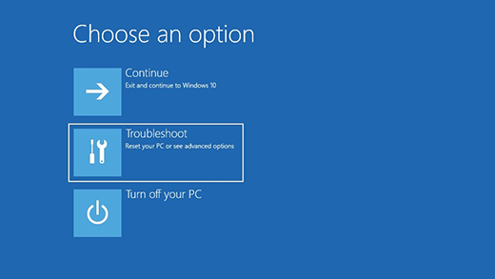

Use the Startup Repair function

Startup Repair helps you fix common problems that can prevent Windows from starting up.

**Note:**If you’ve encrypted your device, you’ll need your BitLocker key to start in safe mode.

First, you need to enter the Windows Recovery Environment (winRE). To do this, you will repeatedly turn your device off, then on:

1. Hold down the power button for 10 seconds to turn off your device.
2. Press the power button again to turn on your device.
3. On the first sign that Windows has started (for example, some devices show the manufacturer’s logo when restarting) hold down the power button for 10 seconds to turn off your device.
4. Press the power button again to turn on your device.
5. When Windows starts again, hold down the power button for 10 seconds to turn off your device.
6. Press the power button again to turn on your device.
7. This time, allow your device to fully start up.
8. Select **Advanced options**.  
   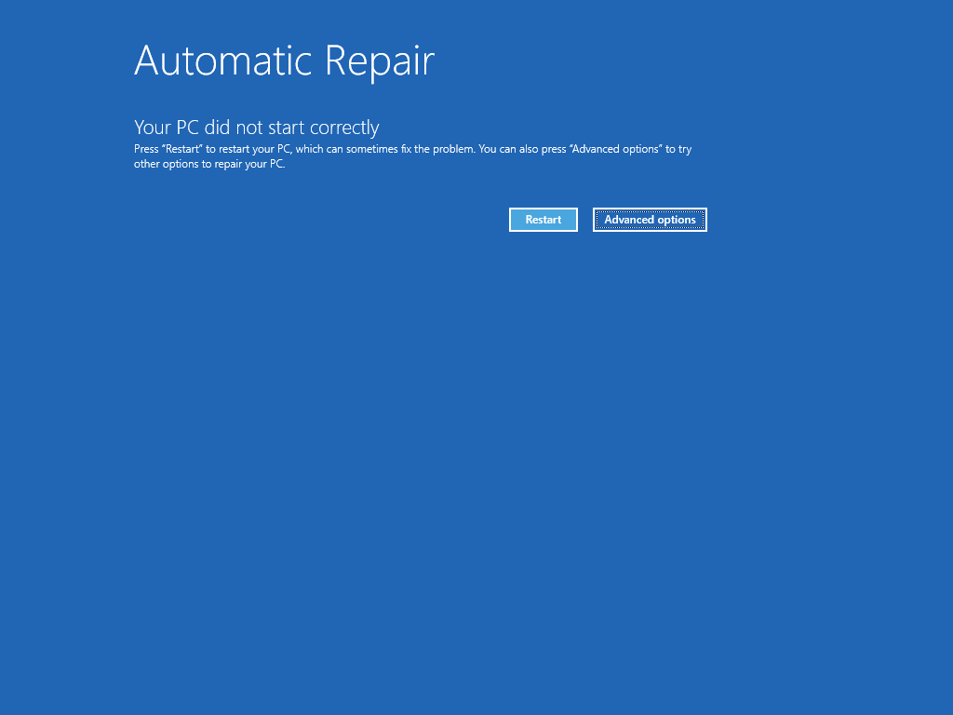
9. Now that you're in winRE, on the **Choose an option** screen, select **Troubleshoot**> **Advanced options**> **Startup Repair**> **Restart**.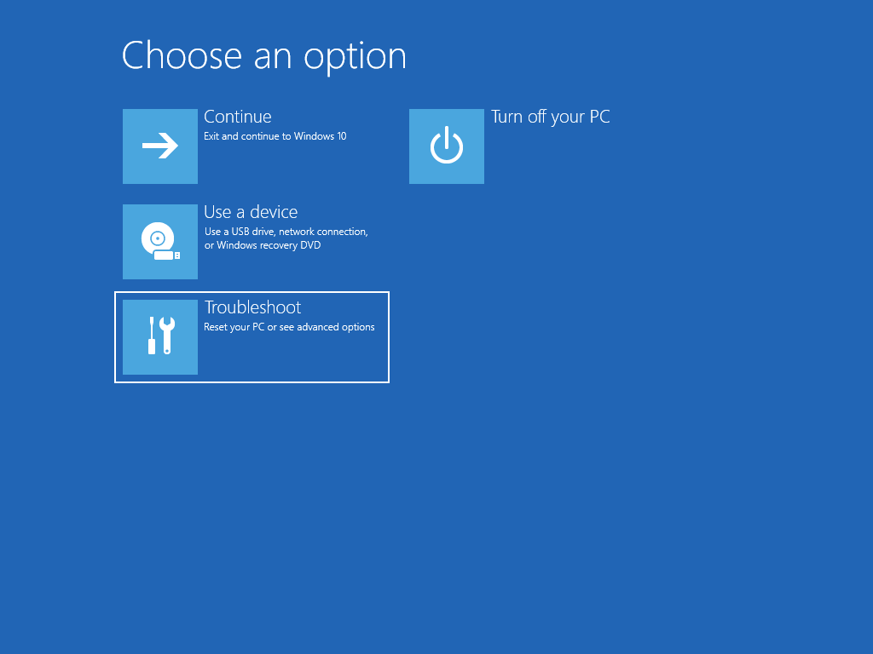  
   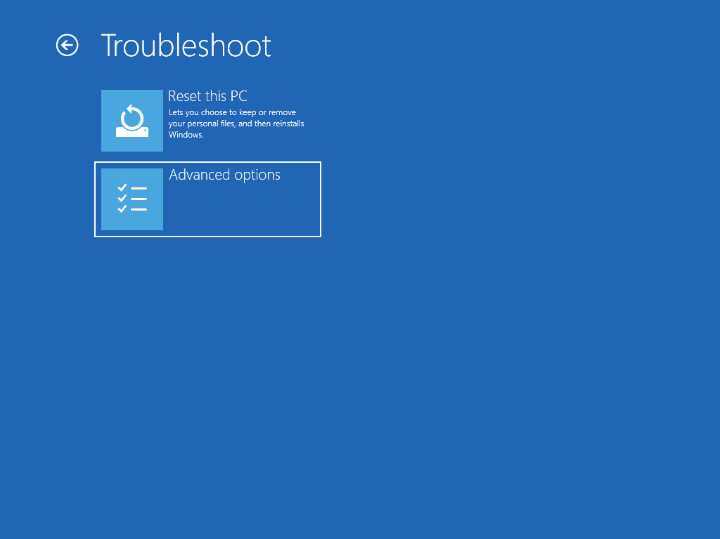  
   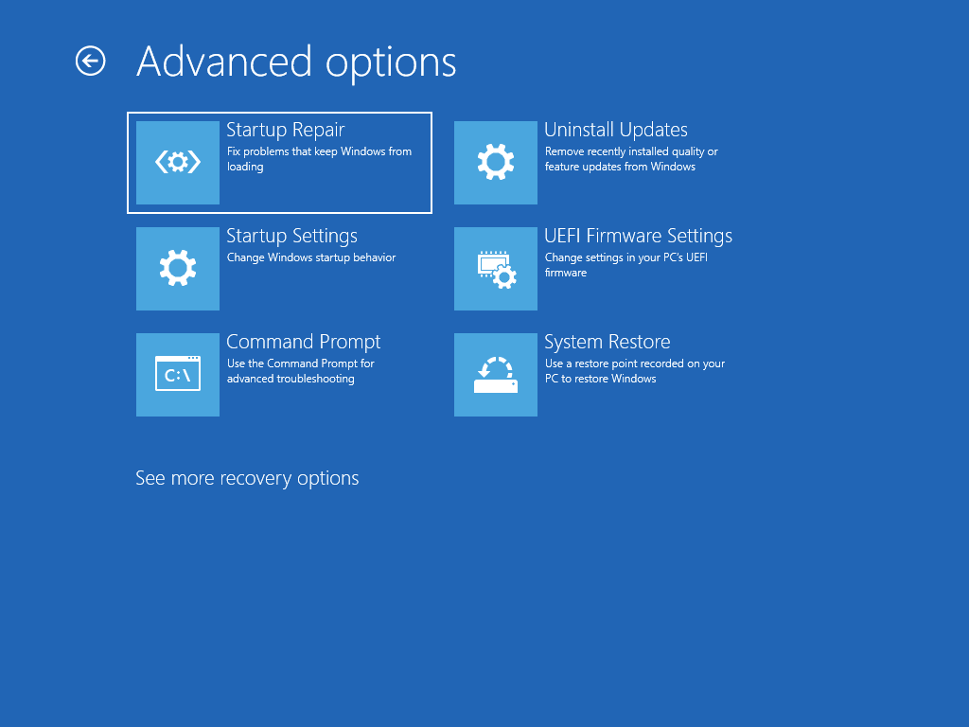

Use installation media to reinstall Windows 11

**Note:**If you suspect that your device has been infected, make sure that your antivirus software is up to date. You can also reinstall Windows completely by starting your device using the installation media and performing a clean installation of Windows.

**To reinstall Windows 11 while Windows is running:**

1. Connect the installation media you created to your PC.
2. Open **File Explorer** and select the drive with the installation media.
3. From the root directory of the drive, double-click setup.exe, and then select **Yes**when asked if you’d like to allow the app to make changes to your device.
4. Select **Change what to keep**.
5. Select one of the following options, and then select Next:
   * **Keep personal files and apps** – This will preserve your personal data, apps, and settings.
   * **Keep personal files only** – This will preserve your personal data and settings, but all your apps will be removed.
   * **Keep nothing** – This will remove all personal data, settings, and apps.

**Warning:**You cannot undo a reinstallation of Windows 10. Be sure to back up your files first if you choose the **Keep nothing**option.

1. To finish, select **Install**to start reinstalling Windows 11 on your PC.

Your PC will restart several times during the reinstallation.

**To reinstall Windows 11 by starting your PC using installation media:**

1. Connect the installation media you created to your PC.
2. Start your PC using the installation media.

**Note:**Check with the PC manufacturer on how to start the PC using media.

1. When Windows Setup starts, select **Next**and then **Install now**.
2. If you have a Windows 11 product key, enter it when prompted. Otherwise, select **I don’t have a product key**.
3. If prompted, select a Windows edition (e.g. Home, Pro) to install and then select **Next**.
4. When prompted to choose a type of installation, select **Custom: Install Windows only (advanced)**.
5. Select the disk or partition to which Windows 11 should be installed.

**Note:**If you suspect that your PC has been infected, consider deleting the existing partitions and reinstalling Windows 11 onto a clean disk. Your data on any deleted partitions will be lost.

1. Select **Next**to start reinstalling Windows 11 on your PC.

Your PC will restart several times during the reinstallation.

Use installation media to restore your PC

**Important:**If you’ve encrypted your device, you’ll need your BitLocker key to use a recovery drive to restore or reset your PC If you don’t know your BitLocker key, see [Find my BitLocker recovery key](https://support.microsoft.com/en-us/windows/find-my-bitlocker-recovery-key-fd2b3501-a4b9-61e9-f5e6-2a545ad77b3e).

If your PC won't start and you haven't created a recovery drive, download installation media and use it to restore from a system restore point or reset your PC.

1. On a working PC, go to the [Microsoft software download website](https://www.microsoft.com/software-download/windows11).
2. Download the Windows 11 media creation tool and then run it.
3. Select **Create installation media for another PC**.
4. Choose a language, edition, and architecture (64-bit or 32-bit).
5. Follow the steps to create installation media, and then select **Finish**.
6. Connect the installation media you created to your nonfunctional PC, and then turn it on.
7. On the initial setup screen, enter your language and other preferences, and then select **Next**. If you don't see the setup screen, your PC might not be set up to boot from a drive. Check your PC manufacturer's website for info on how to change your PC's boot order, and then try again.
8. Select **Repair your computer**.
9. On the **Choose an option** screen, select **Troubleshoot**. From there, you can:
   * Restore from a system restore point by selecting **Advanced options**> **System Restore**. This will remove recently installed apps, drivers, and updates that might be causing your PC problems. Restoring from a restore point won’t affect your personal files.

Use a recovery drive to restore or recover your PC

**Important:**If you’ve encrypted your device, you’ll need your BitLocker key to use a recovery drive to restore or reset your PC If you don’t know your BitLocker key, see [Find my BitLocker recovery key](https://support.microsoft.com/en-us/windows/find-my-bitlocker-recovery-key-fd2b3501-a4b9-61e9-f5e6-2a545ad77b3e).

If your PC won’t start, you can use a recovery drive to restore from a system restore point or recover your PC. For info on how to create a recovery drive on a working PC, see [Create a recovery drive](https://support.microsoft.com/en-us/windows/create-a-recovery-drive-abb4691b-5324-6d4a-8766-73fab304c246).

**Note:**If you are using a Surface, see [Creating and using a USB recovery drive for Surface](https://support.microsoft.com/en-us/surface/creating-and-using-a-usb-recovery-drive-for-surface-677852e2-ed34-45cb-40ef-398fc7d62c07) to download and create a USB recovery image specifically for your Surface device.

To restore or recover using the recovery drive:

1. Connect the recovery drive and turn on your PC.
2. Press **Windows logo key** + **L**to get to the sign-in screen, and then restart your PC by pressing the Shift key while you select the **Power button** > **Restart**.
3. Your PC will restart in the Windows Recovery Environment (WinRE) environment.
4. On the **Choose an option** screen, select **Troubleshoot**, and then select one of the following two options. (If you don’t see the **Choose your option** screen, your PC might not be set up to boot from a drive. Check your PC manufacturer’s website for info on how to change your PC’s boot order.)



* To restore from a system restore point, select **Advanced Options**> **System Restore**. This won't affect your personal files, but it will remove recently installed apps, drivers, and updates that might be causing your PC problems.
* To reinstall Windows 11, select **Advanced Options**> **Recover from a drive**. This will remove your personal files, apps and drivers you installed, and changes you made to settings.

Go back to your previous version of Windows

For a limited time after upgrading to Windows 11, you’ll be able to go back to your previous version of Windows by selecting **Start** > **Settings** > **System** > **Recovery**. Next to **Go back**, **select Go back**. This will keep your personal files, but it'll remove apps and drivers installed after the upgrade, as well as any changes you made to settings. In most cases, you'll have 10 days to go back.   
[**Open Recovery settings**](ms-settings:recovery?activationSource=SMC-Article-12415)

To go back, you'll need to:

* Keep everything in the windows.old and $windows.~bt folders after the upgrade.
* Remove any user accounts you added after the upgrade.
* Have the USB drive you used to upgrade to Windows 11 (if you used one).

**Note:**The option in **Settings** to go back to your previous version of Windows is only available for a limited time after upgrading.

Info for Windows Insiders

If you’re an Insider and the current preview build isn’t working for you, select **Start** > **Settings** > **System** > **Recovery**. Next to **Go back**, select **Go back**. This won’t remove your personal files, but it’ll remove recently installed apps and drivers, and change settings back to their defaults.

Going back to an earlier build won’t remove you from the Insider Program. When the next preview build is ready, it'll be installed on your PC.

Restore from a system restore point

This option takes your PC back to an earlier point in time, called a system restore point. Restore points are generated when you install a new app or driver, and when you [create a restore point manually](https://support.microsoft.com/en-us/windows/create-a-system-restore-point-77e02e2a-3298-c869-9974-ef5658ea3be9). Restoring won’t affect your personal files, but it will remove apps, drivers, and updates installed after the restore point was made.

1. In the search box on the taskbar, type **control panel**, and then choose it from the list of results
2. In the **Control Panel** search box, type **recovery**.
3. Select **Recovery**> **Open System Restore**.
4. In the **Restore system files and settings** box, select **Next**.
5. Select the restore point that you want to use in the list of results, and then select **Scan for affected programs**.

**Notes:**

* + If you don’t see the restore point that you want to use, select the **Show more restore points** check box to see more restore points.
  + If you’re not seeing any restore points, it might be because system protection isn’t turned on. Here’s how to check:
    1. In the search box on the taskbar, type **control panel**, and then choose it from the list of results.
    2. In the **Control Panel** search box, type **recovery**.
    3. Select **Recovery**> **Configure System Restore**> **Configure**and see if the **Turn on system protection** option is selected.
       - If the **Turn on system protection** option is not selected, system protection isn’t turned on and there aren't any restore points. In this scenario, you won't be able to recovery your PC using a system restore point and will need to use one of the other recovery options listed on this page.
       - If the **Turn on system protection** option is selected, continue with step 6.

1. You'll see a list of items that will be deleted if you remove this restore point. If you're OK with the deletions, select **Close**> **Next**> **Finish**.

Information from Microsoft Support